
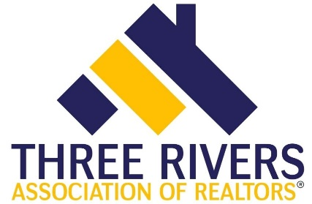
COR 1900, Illinois Core, 4-hour core credit

Course Date: Thursday, January 27, 2022 |  |  |  |  |  |  |  |  | Course Time: 8:30am - 12:30pm
Presented by: Three Rivers Association of REALTORS® |  |  |  |  |  |  |  |  | Course # 564003203
Course Description:  The CORE education curriculum is designed to address  license law, agency duties, fair housing Laws, advertising issues, and escrow obligations, along with changes and trends  in the industry. Case studies, polling questions and discussions  will help students recognize risk management procedures as  well as best practices for successful client experiences. |  |  |  |  |  |  |  |  | Instructor: Lynn Madison  Price: Free for members  $35 for non-members  Three Rivers Association of REALTORS®  303 Springfield Avenue  Joliet, IL 60435
REGISTRATION
If you require special accommodations due to a disability, please describe the accommodation(s) requested:
Name: |  |  |  |  |  |  |  | NRDS or  License #:
Business Address:
City/State |  |  |  |  |  |  |  |  | Zip:
Email: |  |  |  |  |  |  |  |  | Phone:
Payment type: |  |  | Check |  |  | Credit/Debit: Visa Mastercard Discover Amex
Account #: |  |  |  |  |  |  | Expires: |  |  |  |  |  |  | Security  Code:
Signature:
Make check payable to: |  |  |  |  | Three Rivers Association of REALTORS®
Submit registration to: |  |  |  |  | Molly Babyak
Email: |  | molly@trarealtors.net |  |  |  |  |  |  | Phone: |  |  |  | 815-744-4520

