
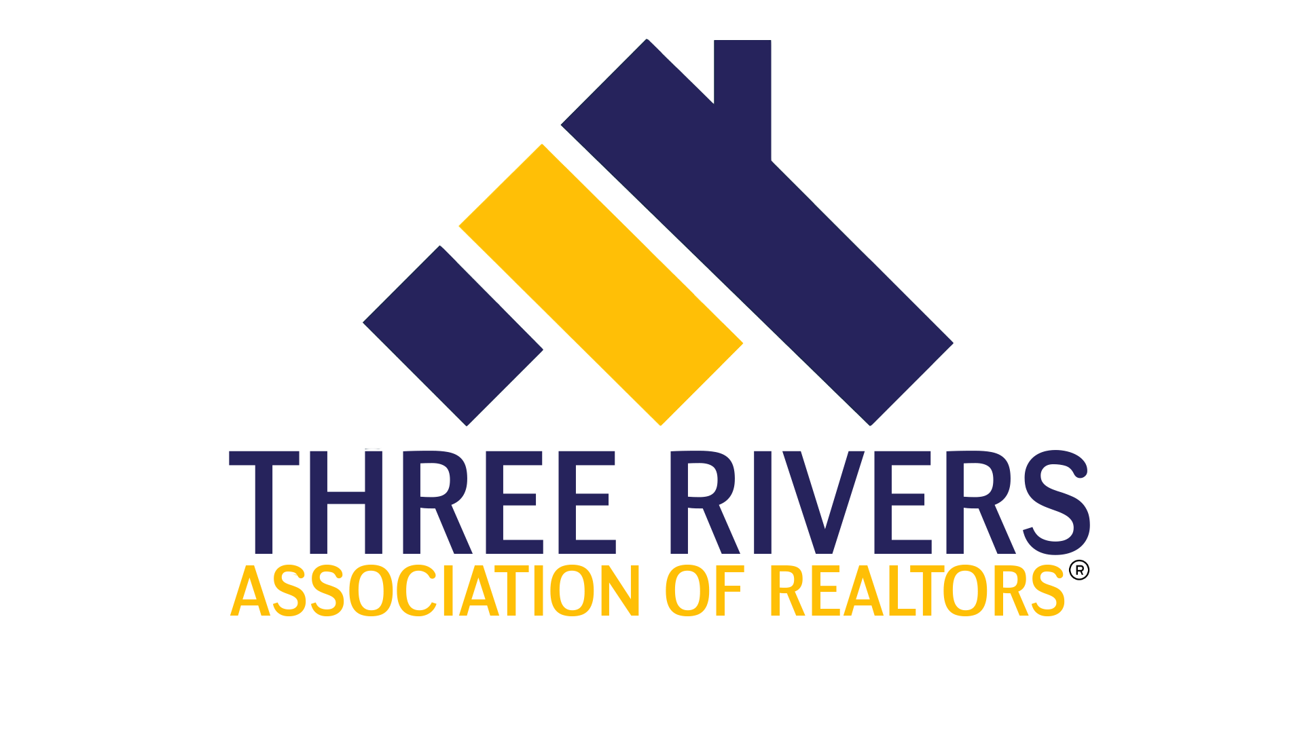
RD 982 Sexual Harassment Prevention & Safety
2 hour elective
January 27, 2022 |  |  |  |  |  |  |  |  | 1:30pm -3:30pm
Presented by: Three Rivers Association of REALTORS® |  |  |  |  |  |  |  |  | Course #564003296
Course Description  This 2-hour elective course is designed to meet the requirements of sexual harassment prevention training required for all IDFPR licensees. In addition, it provides the student with information and training for safe interaction with the public in real estate transactions. |  |  |  |  |  |  |  |  | Instructor: Lynn Madison
Course Location:
Three Rivers Association Of Realtors
303 Springfield Ave
Joliet, IL 60435

Free for members of Three Rivers.
$35 for non-members.

REGISTRATION
If you require special accommodations due to a disability, please describe the accommodation(s) requested:
Name: |  |  |  |  |  |  |  | NRDS or  License #:
Business Address:
City/State |  |  |  |  |  |  |  |  | Zip:
Email: |  |  |  |  |  |  |  |  | Phone:
Payment type: |  |  | Check |  |  | Credit/Debit: Visa Mastercard Discover Amex
Account #: |  |  |  |  |  |  | Expires: |  |  |  |  |  |  | Security  Code:
Signature:
Make check payable to: |  |  |  |  | Three Rivers Association of REALTORS®
Submit registration to: |  |  |  |  | Molly Babyak
Email: |  | molly@trarealtors.net |  |  |  |  |  |  | Phone: |  |  |  | 815-744-4520
Postal Mail:

