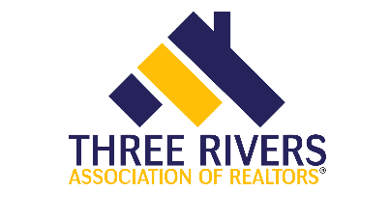


RD 908 Conflict Resolution, Rights and Remedies
3 hour elective
Course Date: Monday, March 14th |  |  |  |  |  |  |  |  | Time: 1pm – 4pm
Presented by:  Three Rivers Association of REALTORS® |  |  |  |  |  |  |  |  | Course 564002974
Course Description:  REALTORS® ADHERING TO THE Code of Ethics have pledged to high standards of cooperation with their fellow licensees. When conflicts arise, resolution efforts are highly recommended for the more immediate agreeable solutions as well as better long-term relationships. This course will highlight and compare certain rights licensees have as outlined in the Code of Ethics, Illinois License Law, local MLS Rules and Regulations and NAR MLS policies. Also covered is an over of various options for formal dispute resolution including the complaint filing process with IDFPR, Ethics and Arbitration hearings, Mediation, Ombudsman and the IR Citation program. |  |  |  |  |  |  |  |  | Instructor: Chris Read
Course Location:
Three Rivers Assn. of Realtors
303 Springfield Ave.
Joliet, IL 60404

Members: FREE
Non Members: $35

REGISTRATION
If you require special accommodations due to a disability, please describe the accommodation(s) requested:
Name: |  |  |  |  |  |  |  | NRDS or  License #:
Business Address:
City/State |  |  |  |  |  |  |  |  | Zip:
Email: |  |  |  |  |  |  |  |  | Phone:
Payment type: |  |  | Check |  |  | Credit/Debit: Visa Mastercard Discover Amex
Account #: |  |  |  |  |  |  | Expires: |  |  |  |  |  |  | Security  Code:
Signature:
Make check payable to: |  |  |  |  | Three Rivers Association of Realtors
Submit registration to: |  |  |  |  | Molly Babyak
Email: |  | molly@trarealtors.net |  |  |  |  |  |  | Phone: |  |  |  | 815-744-4520
Postal Mail: |  |  |  | 303 Springfield Ave, Joliet, IL 60404

