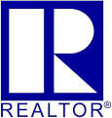
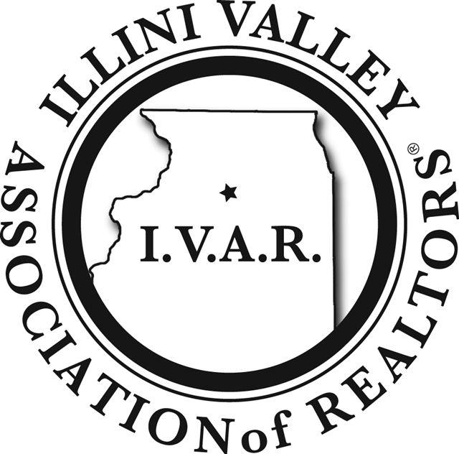
Illini Valley Association of REALTORS®
In conjunction with
Illinois REALTORS®
Offers:

12 Hour Broker Management Course BME 1804

October 6th – 7th, 2022

Sue Miller,
INSTRUCTOR

Registration and pre-payment is required.
General Information

- You are required to attend the sessions in their entirety both days of class.
- You will be required to sign in and out during each day to validate your seat time.
- No Exam Required.
- All courses start promptly on time. LATE ARRIVALS WILL NOT BE ADMITTED. You will not receive CE credit or refund.
- The NEW Broker Management course is designed to assist Managing Brokers and Sponsoring Brokers to function, remain current and compliant, manage risk, perform and succeed in today’s real estate environment. This 12 hour continuing education course will meet the requirements for those hours of continuing education required to renew the Managing Broker license in Illinois.

REGISTER TODAY!

NAME: _______________________________________

REAL ESTATE LICENSE #: ______________________

HOME ADDRESS: ______________________________

CITY, STATE, ZIP: ______________________________

CELL PHONE: __________________________________

EMAIL ADDRESS: ______________________________

OFFICE NAME:_________________________________

OFFICE PHONE:________________________________

LOCAL BOARD: ________________________________

PRICE: $149.00 Members - $199.00 Non-Members

SCHEDULE BOTH DAYS:
Check In 8:45 a.m.
Class Begins: 9:00 a.m.
Lunch on your own: 12:00 p.m.
Class Begins: 1:00 p.m.
Class Ends: 4:00 p.m.

Important Notice: If you have any disabilities LOCATION: City of Peru
that require special accommodations, please 1901 Fourth St.
identify those specialty needs: Peru, Illinois
________________________________________
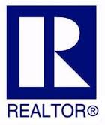

_________________________________
_________________________________
BME 1804: IAR #2022-

