
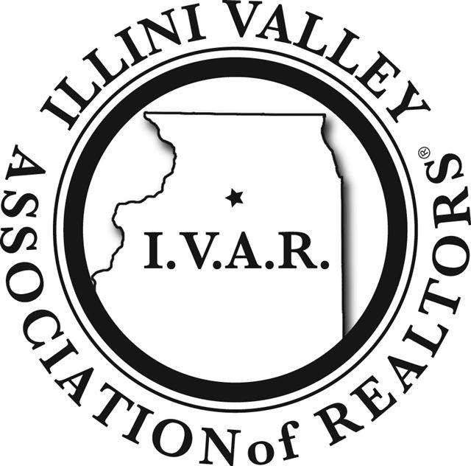

Illini Valley Association of REALTORS®
In conjunction with

Illinois REALTORS®
Offers:

.

COR 1906 – CORE CE: This course will provide attendees with the knowledge and skills necessary to protect consumers, enhance the professionalism of the real estate brokerage industry and prevent violations of the Real Estate Act. 4 Hours CORE CE Credit 564003753

ETH 1530: Understanding the Code of Ethics and its requirements makes us better REALTORS®. This course will walk you through the articles of the Code that are most misunderstood and/or are most violated. Bringing the very best representation to our buyer and seller clients is our number one goal and following the Code can help you do that. 3 Hours Elective CE Credit 564003064

I am a: IVAR Member IR Member Non-Member

Fees: IVAR Members: $45.00 COR 1900 $35.00 ETH 1530
IAR Members: $55.00 COR 1900 $45.00 ETH 1530
Non-Member: $65.00 COR 1900 $55.00 ETH 1530

Name: ________________________________________________

Home Address: ________________________________________

City/State/ Zip: _________________________________________

Local Board: __________________________________________

Email Address:________________________________________

License #_____________________________________________

Company Name: _______________________________________

Office Phone: ______________ Cell Phone: ______________

I wish to attend on March 28th, 2023: (check one or all)

___ COR 1900 ____ ETH 1530

All courses start promptly on time.
LATE ARRIVALS WILL NOT BE ADMITTED!

Send reservation with payment to:
Illini Valley Assoc. of Realtors 1125 Peoria St., Peru, IL 61354

Total amount enclosed: $_________ 815-224-1868
ivar@illinivalleyrealtors.org Fax: 815-224-1816

Instructor: Susan Miller
WHEN:

March 28, 2023
COR 1900 9:00 a.m. – 1:00 p.m.
ETH 1530 1:30 p.m. – 4:30 p.m.

Location:
Utica Community Building
200 Mill Street
Utica, IL 61373

Important Notice:
If you have any disabilities that require special accommodations, please identify those specialty needs:
_______________________________________________________________________________________________________________
IAR 2023

